**UK Sibpair: IBD vs IBS**

Data source: UK sib pairs extracted from UKB data (/public/home/xuhm/data/Oxford/UKB)

As reported in UKB paper (Bycroft *et al.* 2018), about 22K sib pairs were detected (page 222). I replicated this results using plink “--genome” command initially. For families had more than 2 siblings only two were extracted herein, and in total about 18K sib pairs were pooled together for analysis.

Figure for IBD sharing between detected relatives. The figure below showed distribution for relatedness pairs which had IBD greater than 0.1 (top-left), and their IBD0 (sharing 0 alleles, down-left), IBD1 (sharing 1 alleles, top-right), and IBD2 (sharing 2 alleles, down-right) for the detected relatives. The blue points had their population characters match that of sib pairs (IBD0=0.25, IBD1=0.5, and IBD2=0.25), and were used for analysis.

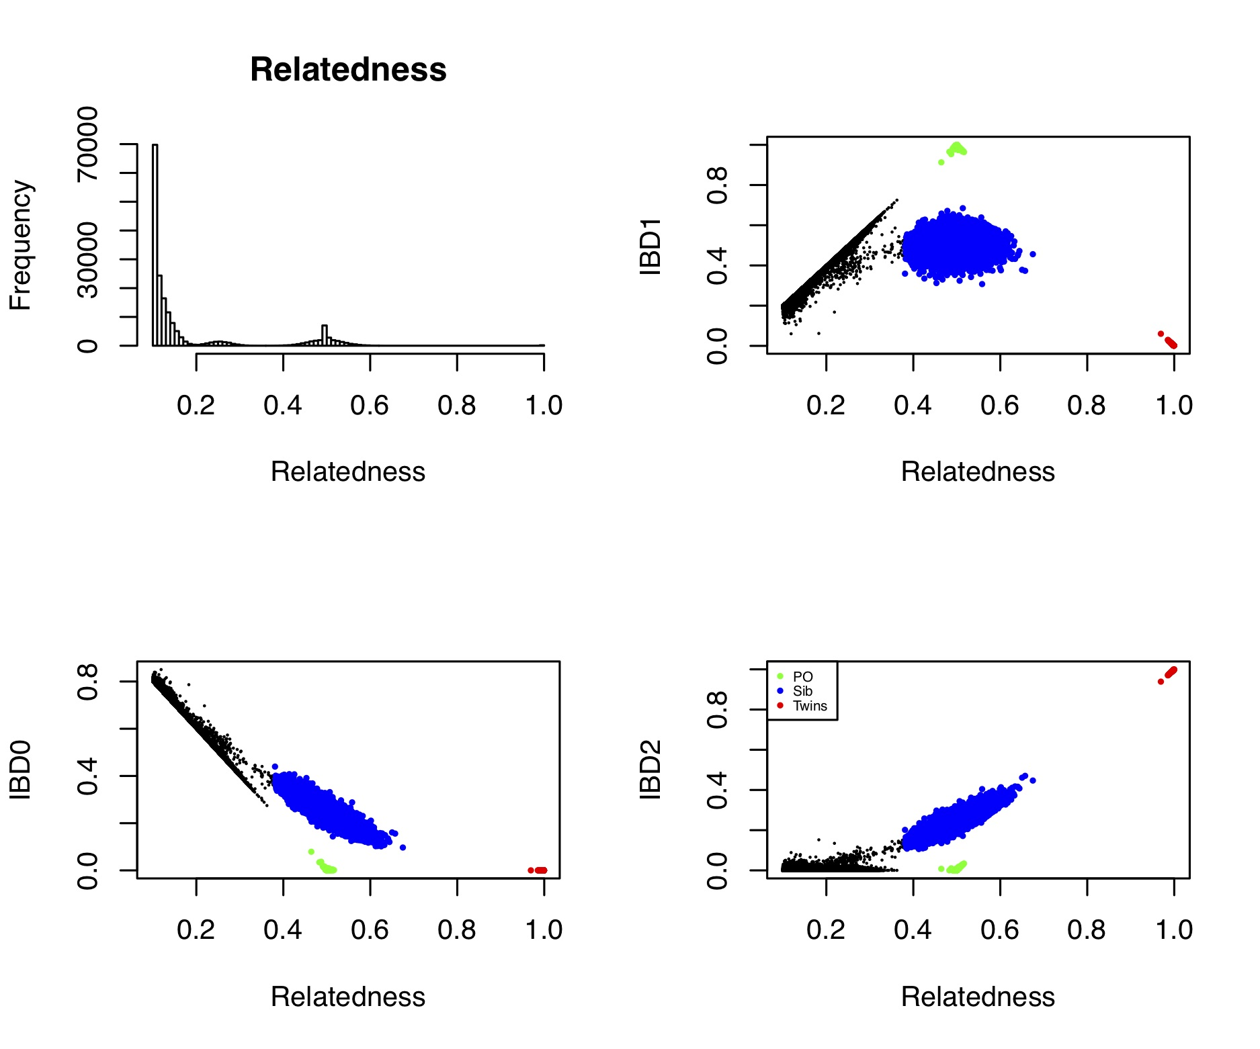

In addition, an alternative command “--make-king” (Manichaikul *et al.* 2010), has been included in plink2. “--make-king” was consistent to IBD as reported in “--genome”, figure below. Of note, in UKB paper, the relatedness was detected using the statistic identical to “--make-king”.



Comparison of VC as estimated in HE. The relatedness was estimated in various ways as below.

The heritability could be roughly estimated as b1/b0.

|  |  |  |  |
| --- | --- | --- | --- |
| Height |  |  |  |
| Relatedness | b0 | b1 |  |
| IBS (18117 individuals) | 0.999 | -0.383 | Extracted one of the sibs from the data, and an unrelated sample was constructed. This one was estimated at population-level. |
| IBS (18117 pairs) | 2.256 | -1.56 | Sib pairs but their relatedness were measured in IBS; their mean IBS =0.466, with sd of 0.04 |
| Genome (18117 pairs) | 1.889 | -0.73 | Relatedness measured as “--genoem” in plink2 |
| Make-king (18117 pairs) | 1.77 | -0.49 | Relatedness measures as “--make-king” in plink2 |

The estimation for BMI seemed not good.

|  |  |  |  |
| --- | --- | --- | --- |
| BMI |  |  |  |
| Relatedness | b0 | b1 |  |
| IBS (18117 individuals) | 0.999 | -0.16 | Same as above |
| IBS (18117 pairs) | 1.246 | 1.00 |  |
| Genome (18117 pairs) | 1.132 | 1.16 |  |
| Make-king (18117 pairs) | 1.06 | 1.31 |  |

Bycroft C., Freeman C., Petkova D., Band G., Elliott L. T., Sharp K., Motyer A., Vukcevic D., Delaneau O., O’Connell J., Cortes A., Welsh S., Young A., Effingham M., McVean G., Leslie S., Allen N., Donnelly P., Marchini J., 2018 The UK Biobank resource with deep phenotyping and genomic data. Nature **562**: 203–209.

Manichaikul A., Mychaleckyj J. C., Rich S. S., Daly K., Sale M., Chen W.-M., 2010 Robust relationship inference in genome-wide association studies. Bioinformatics **26**: 2867–73.